A few photos from the 2006 Dinner.

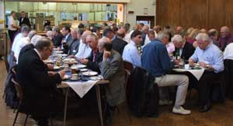

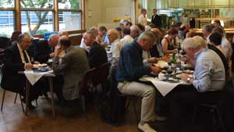

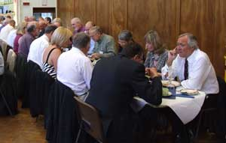

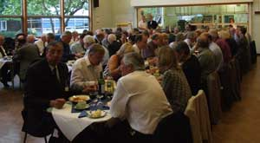

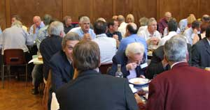
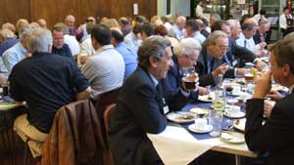

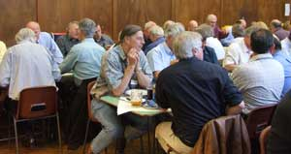

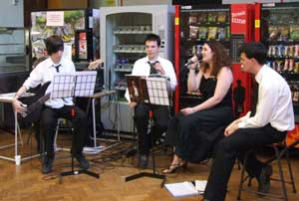

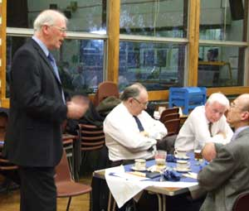

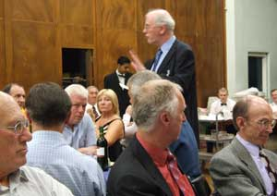

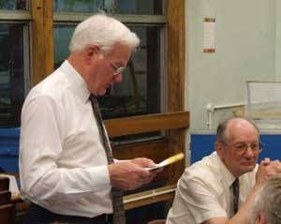

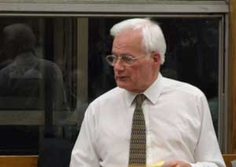

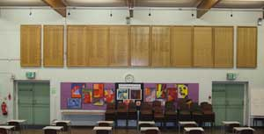

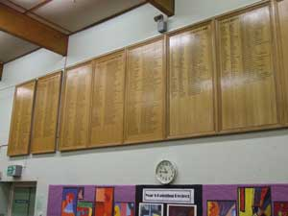

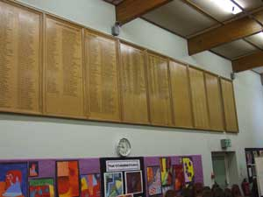

During the Dinner a cheque for £750 was handed to the headmaster - Brian Titterington - as a further payment towards the cost of the Honours Boards, which have been placed on the wall at the back of the main hall. These record the pupils who have gone on to a University.

Guests attending 2006 Dinner

Paul Parker 1962 1976
Guest of Honour
Brian Titterington 1992 2006
President/Headmaster
Peter Franks 1946 1950
John Ince 1954 1958
Jim Austen 1954 1974
Dennis Wells 1954 1959
Paul Dudley 1954 1960
John Gatland 1954 1961
Ken Prebble 1954 1961
John Nunn 1955 1961
Betty Nunn
Paul Oakley 1956(58) 1963
Colin Archer 1956 1961
Roger Hammond 1956 1961
Ralph Smith 1956 1961
Chris Taylor 1956 1962
Mike Sutton 1956 1962
Michael Lyons 1956 1962
John Read 1956 1962
Tony Carpenter 1956 1963
Robin Pitman 1956 1963
Ken Rawlinson 1956 1963
Tony Clark 1956 1963
Michael Samuel 1956 1963
Nigel Bourne 1956 1963
Innis Simpson 1956
Bob Crighton 1956
Mary Orme
Michael Watts 1957 1962
Malcolm Green 1957 1963
Chris Portwine 1957 1965
Keith Potter 1958 1964
David Bailey 1959 1964
Richard Shearman 1959 1964
Jenny Shearman
Ken Service 1959 1966
Colin Fradd 1959 1966
Helen Fradd
Alan Russell 1959 1966
Bob Gammon 1959 1966
Caroline Gammon
Nick Crutchfield 1959 1966
Gail Crutchfield
John Meakins 1959 1964
Peter Bundell 1960 1967
Fiona Bundell
Roy Hoddinott 1961 1965
Terry Rooke 1961 1966
Guest Rooke
Gerry Spice 1961 1966
John Yelding 1961 1966
Guest Yelding
Paul Hills 1961 1968
Geoffrey Spice 1963 1968
John Walker 1965 1970
Anton Syrocki 1965 1972
Howard Little 1965 1972
Chris Proctor 1965 1972
Chris Smith 1967 1974
Paul Munford 1967 1974
Stephen Marsh 1968 1972
Colin Boucher 1969 1974
Ryan Miller 1991 1998

Apologies received from
Rhoda Windiate-Blackmore 1943 1949
Michael Hilton 1949 1953
Brian Cogger 1951 1952
Richard Harcourt 1952 1955
Brian Winch 1954 1958
Bruce Timms 1954
David French 1954
Neil McKay 1954
David Laken 1954
Adrian Hatley 1954
Terry Whiffin 1954
Peter Samson 1956
John Woodard 1956
Michael Parkinson 1954
Terry Staples 1954
David Catchpole 1957
Wally James 1957 1989
John Daley 1963 1992
Marion Miller 1971 1989
Tony Martin 1983 1989

